PurpleSpace ANZ Leadership Roundtable – Summary Report

Introduction

On 27 August PurpleSpace held its ANZ Peer Leadership Roundtable at EY’s Sydney office. With over 20 in-person and more than 30 online participants, the turnout reflected the growing appetite for connection among Disability Employee Network (DEN) leaders across Australia and New Zealand.

We offer our thank you to our hosts at EY, Zoe Field, Kaz Geering, Patrick Medd, and Laura Grant, for the warm welcome and their leadership.

Participants discussed the role of disability ERG/Network leaders in ANZ in:
- Supporting their organizations to improve the delivery of workplace adjustments/accommodation
- Developing the confidence of colleagues with disabilities to request the adjustments they need to thrive

This Roundtable marked a significant milestone: our first hybrid ANZ event since PurpleSpace was founded in the UK in 2015. It represents a pivotal moment for the global disability ERG/Network movement and a powerful step forward in building connection and community between DEN leaders across the region.

PurpleSpace Background and Purpose

PurpleSpace is the world’s only professional development and networking hub for disability Employee Resource Group (ERG)/Network leaders, champions and allies.

Established in 2015, our 170+ member organizations employee an estimated 1.5 million employees with disabilities between them. Our services are now accessed by over 4,000 disability ERG/Network leaders, from over 56 countries.

Sitting at the intersection of the disability and professional development sectors, our mission is to help organizations and individuals build disability confidence ‘from the inside out’. We do this by accelerating the global growth of the disability ERG/Network movement and developing the inner confidence of every employee with a disability.

Graphic: PurpleSpace at the intersection of the disability and professional development sectors:
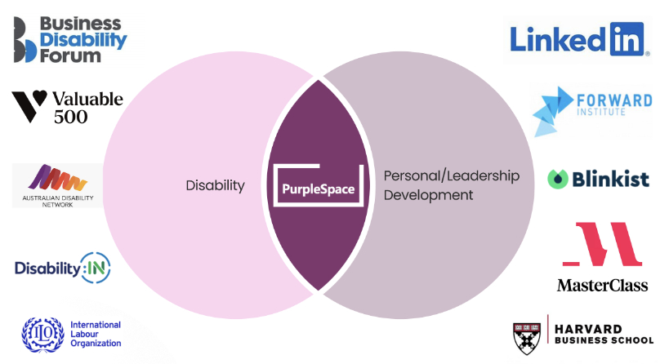

Summary of Session on WPA and DENs

The session offered a dynamic exploration of the role of disability ERG/Network leaders in ANZ in improving workplace adjustment/accommodation provision.

The conversation centered on confidence-building, storytelling, and grassroots leadership as key drivers of inclusion as participants discussed the way that disability ERG/Networks are:

Supporting their organizations to improve the delivery of workplace adjustments/accommodation by surfacing the lived experience of employees with disabilities.
- Developing the confidence of colleagues with disabilities to request the adjustments they need to thrive.

Key insights:

- Promoting Storytelling: ERGs/DENs play a vital role in creating safe spaces for employees to share their experiences. This storytelling not only builds inner confidence but also helps demystify WPA and encourages others to seek support.

- Grassroots Engagement for Policy Improvement: Several ERG/DEN leaders shared plans to initiate internal conversations and tap into existing resources to better support their organisations. This grassroots approach was recognised as a vital channel for surfacing lived experiences and bottom-up insights, helping to inform and shape more inclusive and effective policy improvements. It was seen as essential for driving sustainable cultural change.

- Leadership Engagement: Inspired by PurpleSpace’s Confident Conversation podcast where executives with disabilities share what they have learned navigating disability and a successful career, attendees expressed strong interest in finding ways to share the stories of disabled execs in ANZ. This was viewed as a strategic way to drive both cultural and organisational transformation.

- Policy Activation: DENs are actively promoting WPA policies and practical tools such as adjustment passports and profile tools. These resources empower employees to confidently request the support they need.
Delegates shared their views on how the ANZ disability ERG/Network movement might develop over the next three years and the support that would enable its growth.
What would a thriving Australia and New Zealand DEN movement look like in 3 years’ time?
- Measurable growth and impact demonstrate the value contribution of the ANZ disability ERG/DEN movement.
- ERG/DENs in ANZ collaborating and creating impact locally and globally.
- More senior leaders with disabilities sharing their experiences to help others build confidence and trust.

The three things that would support the growth and impact of the ANZ ERG/Network movement:
- Regular networking and collaboration between ANZ ERG/DEN leaders
- Learning & Development to develop leadership capacity of ANZ ERG/DEN leaders.
- Tailored collateral to support employees with disabilities in ANZ to develop the confidence to share aspects of their story and request the workplace adjustments they need to thrive.

Our Shared Vision for the Future of Disability Inclusion in ANZ

Your collective responses have shaped a compelling vision for what a thriving Disability Employee Network (DEN) movement could look like by 2028:
- Connected and Collaborative
A dynamic, well-connected community of DEN and ERG leaders meeting regularly across organisations and borders to share resources, insights, and mutual support.
- Data-Informed Progress
Transparent sharing of data on DEN membership, workplace adjustments, and strategic outcomes to monitor progress and guide decision-making.
- Leadership and Representation
Senior leaders actively champion disability inclusion, with more people with disabilities in leadership roles and recognised for their strategic contributions.
- Strategic Integration
Accessibility and inclusion are embedded into core business processes, with DENs resourced and acknowledged as key drivers of organisational change.
- Cultural Normalisation
A future where inclusion is seamless, diversity is celebrated, and asking for support is met with confidence and understanding.
Looking Ahead: PurpleSpace’s Three-Year ANZ Strategy
At the upcoming ANZ Peer Leadership Roundtable, PurpleSpace will present its three-year strategy for the region. Key strategic questions we will explore include:
- Tailoring Learning and Development
How can we better shape our learning and development opportunities to meet the specific needs of the ANZ audience?

- Effective Convening Models
What is the most impactful way to bring ANZ ERG/DEN leaders together? Should we prioritise in-person, virtual, or hybrid formats?

- Investment for Impact
What level of investment is required to achieve the outcomes we envision for the ANZ region?

- Global Integration
What role should the ANZ ERG/DEN community play within PurpleSpace’s global Network of Networks?

What’s Coming Up
Upcoming events include:
- #PositivelyPurple Sydney Hub hosted globally by CISCO: 5 November 2025
- ANZ Peer Group Roundtable: February 2026
Together, we are shaping a movement that is collaborative, bold, data-informed, and deeply human. Thank you for your leadership, your stories, and your commitment to building a more inclusive future.

